F – If-Else Structures

Student Exercises – Documentation

# Exercises Overview

The following exercises are given as practice for this topic. The recommended order of the exercises is as follows.

1. **Rectangle** – “All squares are rectangles, but not all rectangles are squares.” This class represents a simple rectangle with a height and width. From this information, the area, perimeter and diagonal can be obtained; it can also be determined if the rectangle is or is not square.
2. **HazardousMaterial** – The HazardousMaterial class is a simple representation of the six main classes of hazardous materials (A through F). This class maps a classification code with a general description of the material’s classification:
   1. **Class A** – Compressed Gas
   2. **Class B** – Flammable and Combustible Material
   3. **Class C** – Oxidizing Material
   4. **Class D** – Poisonous and Infectious Material
   5. **Class E** – Corrosive Material
   6. **Class F** – Dangerously Reactive Material
3. **CurrencyCalculator** – This exercise extends the previous CurrencyCalculator exercise by allowing the conversion from a foreign currency to US dollars.
4. **GravityCalculator** – This exercise extends the previous GravityCalculator exercise by allowing the conversion to a weight on Earth from a weight on another planet in our solar system.

# Rectangle

“All squares are rectangles, but not all rectangles are squares.” This class represents a simple rectangle with a height and width. From this information, the area, perimeter and diagonal can be obtained; it can also be determined if the rectangle is or is not square.

## Problem Statement

Write the code for the Rectangle class. The solution must meet the following requirements:

* Should get and set the height and the width
* Should calculate the area, the perimeter and the diagonal
  + The formula for the diagonal is $\sqrt{{width}^{2} + {height}^{2}}$
* Should determine if the rectangle is a square

Use the following class diagram when creating your solution.

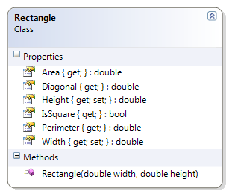

# HazardousMaterial

The HazardousMaterial class is a simple representation of the six main classes of hazardous materials (A through F). This class maps a classification code with a general description of the material’s classification:

**Class A** – Compressed Gas

**Class B** – Flammable and Combustible Material

**Class C** – Oxidizing Material

**Class D** – Poisonous and Infectious Material

**Class E** – Corrosive Material

**Class F** – Dangerously Reactive Material

## Problem Statement

Write the code for the HazardousMaterial class. The solution must meet the following requirements:

* Should return the class code as the classification
* Should get the description for the class, based on the following table

|  |  |
| --- | --- |
| **Class Code** | **Description** |
| A | Compressed Gas |
| B | Flammable and Combustible Material |
| C | Oxidizing Material |
| D | Poisonous and Infectious Material |
| E | Corrosive Material |
| F | Dangerously Reactive Material |

* Should override the ToString() method to get the full description and class code in the following format:
  + “Class ClassCode - Description”

Use the following class diagram when creating your solution.

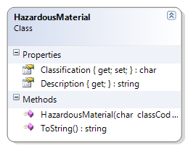

# CurrencyCalculator

This exercise extends the previous CurrencyCalculator exercise by allowing the conversion from a foreign currency to US dollars.

## Problem Statement

A currency exchange store at the international airport needs a program to convert from US dollars to four other currencies: Canadian dollar, Euro, Japanese Yen, and the Great Britain Pound. The store uses a set exchange rate for each currency as established at the start of the day. Write the code for a class called CurrencyCalculator to meet this need. The solution must meet the following requirements (new requirements are in ***green, bold italic*** font):

* Should correctly convert US dollars to the
  + British Pound (GBP)
  + Canadian Dollar (CAD)
  + Euro (EUR)
  + Japanese Yen (JPY)
* ***Should convert an amount to US dollars from any of the supported currencies (GBP, CAD, JPY, and EUR)***
* Should use the correct level of precision when making the exchange; each currency uses a different number of significant digits:
  + CAD, GBP and EUR use two digits
  + JPY uses three digits

To illustrate the possible exchange rates, please refer to the following images.

Currency exchange rates sourced from <http://www.x-rates.com>  
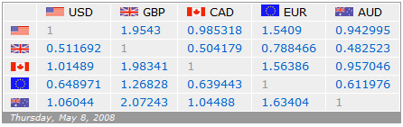

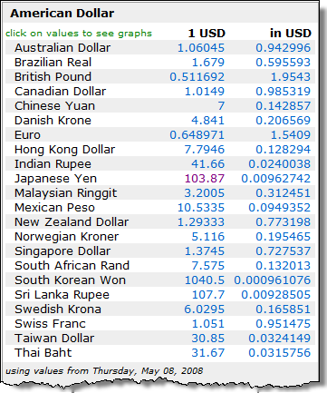

Use the following class diagram when creating your solution.

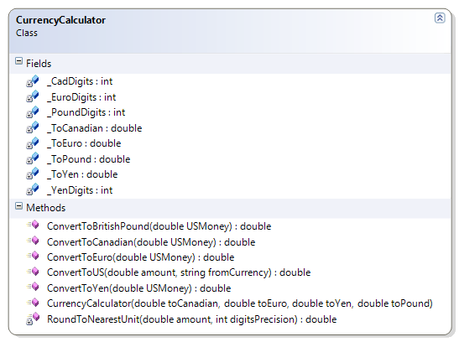

# GravityCalculator

This exercise extends the previous GravityCalculator exercise by allowing the conversion to a weight on Earth from a weight on another planet in our solar system.

## Problem Statement

Write the code needed to convert Earth weights to their equivalent for the other planets in our solar system. The solution must meet the following requirements (new requirements are in ***green, bold italic*** font):

* Should convert a weight in Earth kilograms to their equivalent weight on
  + Mercury
  + Venus
  + Mars
  + Jupiter
  + Saturn
  + Uranus
  + Neptune
* ***Should convert a weight from a specific planet back to the equivalent weight on Earth***

Use the following class diagram when creating your solution.

